PMAN 634

Session 11, Individual Assignment IA-11

Section (A); 20%

11-1: In Session 11, we discussed the goals of project closure; to complete the project and to improve the performance of future projects. In this assignment, you will individually develop a project wrap-up closure checklist that is tailored/unique to your group project that you have worked on throughout the course.

Exercise 1 - Project Closure Checklist: Using the concepts found in Chapter 14 of your textbook and the discussions in Session 11, develop a short (no more than 1 page in length) project closure checklist that you could use to close out your group project. Once you have completed the checklist answer the following:

Question 1 - Project Retrospectives: Advocates of retrospective methodology claim there are distinguishing characteristics that increase its value over past lessons learned methods. What are they? How does each characteristic enhance project closure and review?

Section (B):

11-2(10%): In planning for a new business to start, please list all the steps you need to consider in your planning to create a satisfactory business enterprise.

11-3 (10 points) - For an established small office building, you are assigned as a PM to plan for installation of a security system, while sub-contracting the task of renovating the building by delivering a “Green Structure”. You have selected different sub-contractors to perform their independent identified tasks during the estimated times specified for each. Please plan the best and shortest time you suggest to complete the project, considering the fact that each sub-contractor can perform their tasks independent of others? Please show the best start & finish schedules of work for each independent subcontractor to produce minimum slack, by showing the activities on a Gantt chart.

- Solar Panel installation & necessary circuitry 10 working days
- Changing windows 12 “ days
- Modify HVAC system & internal coil to take
Advantage of Solar system 25 “ days
- Change all electrical bulbs to LED lighting 4 “ days
- Complete painting job of the office 10 “ days
- Install necessary wirings 5 “ days
- Install all Security system devices 10 “ days
- Systems testing and configuration 3 days
11-4 (60 %): Cash Flow Analysis:

A company producing certain products has concluded to have the following estimated data over its 5-year projection plan:

 | 1st year  ($ mil) | 2nd year | 3rd year | 4th year | 5th year | TOTAL  ($ mil)
Total Expenses | 0.75 | 0.70 | 0.65 | 0.7 | 0.75
Cum Expenses
Total Revenues | 0 | 0.85 | 1.2 | 1.3 | 1.4
Cum Revenues

Please plot the above data to represent cumulative costs versus cumulative revenues over the 5-year projections on the following table to extrapolate the breakeven point for this project. Express the minimum amount of investment you need to operate and deliver this project, indicating the best ROI at the end of 5th year, based on:
(a) Take Breakeven value as your needed investment amount;
(b) Cash investment of 20% down & 80% loan.
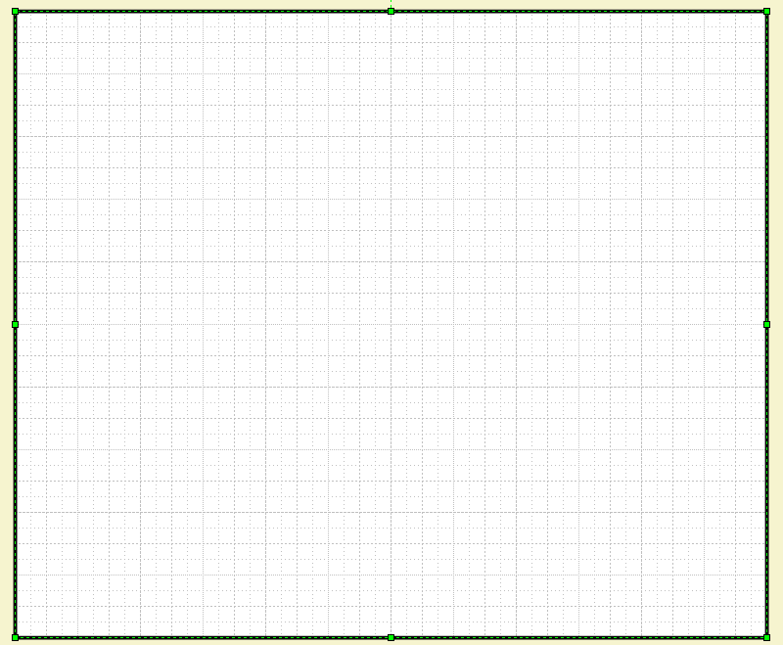
t, year
$ mil

